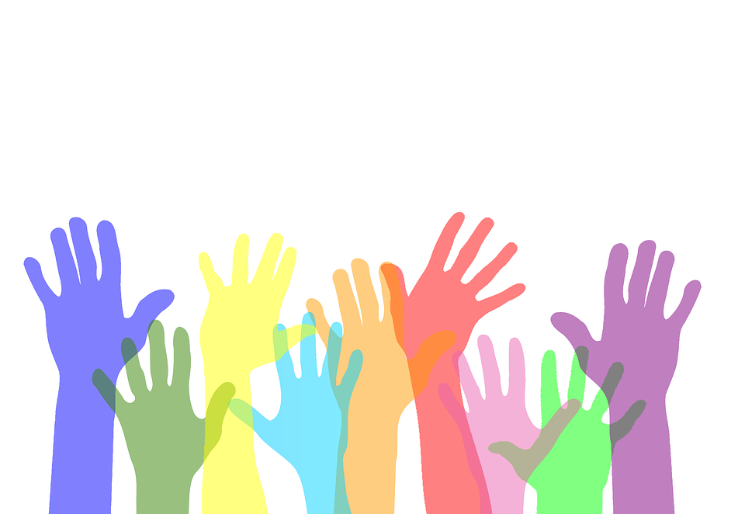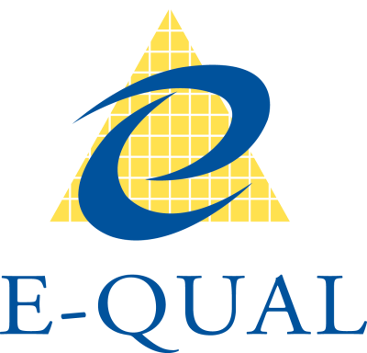

E-Qual Logo

**Effective Communication with People with Disability**

Colourful outstretched hands

Colourful outstretched hands

Effective communication with people with disability is largely no different to effective communication with anyone. Good practices such as active listening, language that suits the audience, body language that matches your words and appropriate eye contact still apply. Some additional tips include:

* Relax and be yourself. People with disability are people first. Their disability is just one the many characteristics that make them who they are.
* Don’t make assumptions about a person’s ability to communicate based on what they look or sound like or who is with them. Assume a person is competent until you are advised otherwise.
* Communicate directly with the person, not their carer or interpreter.
* Use respectful language and don’t ask about a person’s disability unless it is relevant.
* Use clear and concise language and avoid unfamiliar jargon, acronyms and technical terms or explain what they mean.
* Allow enough time, some people need longer to process things and respond.
* Don’t pretend you understand if a person’s speech is unclear. Asking them to repeat something shows that you are genuinely interested in hearing what they have to say.
* Think about the environment you are communicating in. Privacy, safety, background noise, distractions, lighting, comfort, and accessibility may all need to be considered.
* Ask the person what works for them and be flexible about how you communicate. Some people have no specific communication requirements and others may have communication
* SMS – we all use this but particularly useful for people with hearing or speech impairments
* Audio Loops – a permanent, temporary or portable installation for meetings or events that allows people who use hearing devices to connect directly with the PA system
* Closed captions – for videos or movies
* Gesture – we all use this!
* Audio, Braille, large print or Easy English versions of documents
* Australian sign language (Auslan)

**Some Alternative Ways that People with Disability Communicate**



**Organisations that can support your communication with people with**

**particular needs include:**

* **Media Access Australia -** provides a practical resource to support organisations in producing online materials that are suitable for people with cognitive disability [‘Cognitive Disability Digital Accessibility Guide’](http://www.mediaaccess.org.au/digitalaccessibilityservices/cognitiveguide/)
* [**Information Access Group**](https://www.informationaccessgroup.com/index.html) **–** for Easy English documents
* [**National Relay Service**](https://www.communications.gov.au/what-we-do/phone/services-people-disability/accesshub) **–** an easy to use government service that allows people who are deaf, hard of hearing and/or have a speech impairment to make and receive phone calls
* [**TIS National**](https://www.tisnational.gov.au/) **–** interpreting services for people from CALD backgrounds
* [**National Accreditation Authority for Translating and Interpreting (NAATI)**](https://www.naati.com.au/) **–** can provide details of certified translators and interpreters
* [**Vision Australia**](https://www.visionaustralia.org/) **-** provides guidelines on producing documents in accessible formats and has a [Document Accessibility Toolbar](https://www.visionaustralia.org/services/digital-access/document-accessibility-toolbar) for Microsoft Word 2010 onwards
* [**VisAbility**](https://www.visability.com.au/) **-** can covert your documents into Braille or audio
* [**Access Plus WA Deaf**](https://accessplus.org.au/) **–** for Auslan interpreting
* [**E-QUAL Disability Consultants**](https://www.e-qual.net/) **–** can provide training on effective communication with people with disability
* [**People with disability Australia**](https://pwd.org.au/resources/disability-info/language-guide/) **–** provide a language guide for talking about and reporting on disability

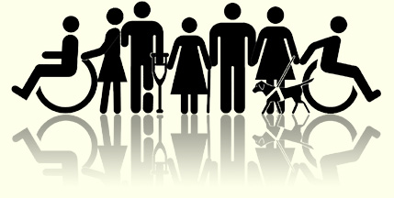

Image: Cartoon figures of a variety of people holding hands