

Colourful outstretched hands

E-Qual Logo

Colourful outstretched hands

**Supporting Volunteers with Disability**

People with disability are the experts about what they need and how to make adjustments so they can be included, so just ask! You can’t ask about the details of someone’s disability or medical condition but you can ask:

***“Do you have an impairment or medical condition that could impact how you do this work? If yes, what support do you need to be able to do your work safely and effectively?”***



**Many supports will cost nothing or very little such as:**

* Ergonomic equipment e.g. an adjustable chair, footrest, height adjustable desk
* Flexible start times
* More frequent rest breaks
* Opportunity to work from home
* Step by step work instructions
* Additional training or mentoring

Image: Cartoon image of a person surrounded by daily needs and activities such as doctors and friends

* Physical modifications to the workplace e.g. ramps or self opening doors
* Specialised equipment e.g. speech recognition software or a portable hearing induction loop
* A personal support worker
* Auslan interpreter
* Disability awareness training for colleagues

**Other supports may be provided with funding, for example through JobAccess or the person’s NDIS plan if they are trying to prepare for employment, such as:**

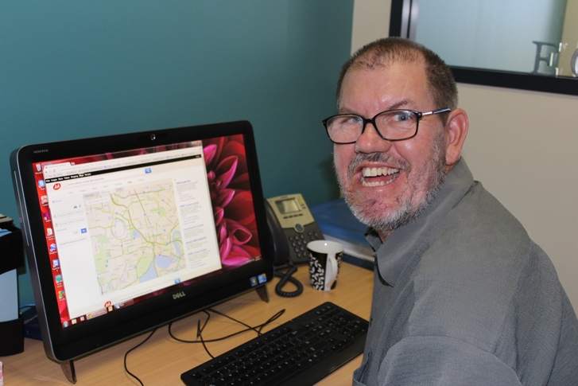

Colourful outstretched hands

Image: Smiling man using a computer to find directions

Image: Wooden scrabble pieces spelling out ‘SUPPORT’

**There are also many free resources to support accessible and inclusive employment practices such as:**

* [Vision Australia](https://www.visionaustralia.org/) provides guidelines on producing documents in accessible formats and has a[**Document Accessibility Toolbar**](https://www.visionaustralia.org/services/digital-access/document-accessibility-toolbar) for Microsoft Word 2010 onwards.
* Media Access Australia has produced a practical resource, the [**‘Cognitive Disability Digital Accessibility Guide’**](http://www.mediaaccess.org.au/digitalaccessibilityservices/cognitiveguide/)**,** to support organisations in producing online materials that are suitable for people with cognitive disability.
* The [Meetings and Events Industry of Australia](http://www.meetingsevents.com.au/) in partnership with the Australian Human Rights Commission developed a comprehensive resource on accessible meeting and events [**‘Accessible Events: A Guide for Meeting and Event Organisers’**](http://www.meetingsevents.com.au/downloads/Accessible_Events_Guide.pdf)**.**

**For further information, visit:**

* [**JobAccess**](https://www.jobaccess.gov.au/) **–** Commonwealth Department providing extensive information about workplace adjustments to support inclusion and opportunities for funding to support (paid) work opportunities
* [**Australian Network on Disability**](https://www.and.org.au/) **–** peak body providing information on best practice in recruiting and employing people with disability
* [**Diversity Council of Australia**](https://www.dca.org.au/) **–** peak body providing information on including people from diverse backgrounds and with diverse skills and abilities